
2026
Azure Windows Virtual Machine Deployment using Terraform
Kyndryl Team
6/29/2026
Project Charter


Project Title
Azure Windows Virtual Machine Deployment using Terraform

Document Information
Item | Details
Project Name | Azure Windows VM Deployment using Terraform
Project Type | Infrastructure as Code (IaC) Implementation
Methodology | Agile
Version | 1.0
Project Duration | 5 Working Days
Sponsor | Course Instructor
Project Manager | Student Team Leader
Team Size | 4–6 Members

Table of Contents
Project Title 1
Document Information 2
1. Project Purpose 4
2. Business Need 4
3. Project Objectives 4
3.1 SMART Objectives 5
4. Project Scope 5
In Scope 5
Out of Scope 6
5. Project Deliverables 6
6. Project Assumptions 7
7. Project Constraints 7
8. Project Milestones 7
9. Success Criteria 8
9.1 Success Metrics (KPIs) 8
10. Stakeholders 8
11. Team Roles 9
12. Risk Summary 9
13. High-Level Schedule 10
14. Budget Estimate 10
15. Communication Plan 11
16. Project Approval 11
17. Project Approval Statement 11
18.Project Closure Checklist 11

1. Project Purpose
The purpose of this project is to design, deploy, configure, and validate a Microsoft Azure Windows Virtual Machine using Terraform. The project provides hands-on experience with Infrastructure as Code (IaC), cloud networking, Azure compute resources, storage management, automation, and infrastructure lifecycle management.

Students will deploy a secure Windows Server virtual machine, configure networking and security, install IIS, attach additional storage, resize the VM, apply governance through resource tagging, and validate the deployment using User Acceptance Testing (UAT).

2. Business Need
Many organizations are adopting Infrastructure as Code (IaC) to automate cloud resource provisioning. Manual deployment is often time-consuming, inconsistent, and error-prone.
This project demonstrates how Terraform can be used to:
- Automate Azure infrastructure deployment.
- Standardize infrastructure configuration.
- Reduce deployment time.
- Improve consistency and repeatability.
- Support DevOps and Cloud Engineering practices.

3. Project Objectives
The project aims to achieve the following objectives:
- Deploy Azure infrastructure using Terraform.
- Create a secure networking environment.
- Deploy a Windows Server 2022 Virtual Machine.
- Configure Remote Desktop access.
- Install IIS automatically.
- Attach a 32 GB Standard HDD managed disk.
- Resize the virtual machine.
- Apply governance tags.
- Validate the infrastructure through testing.
- Produce professional project documentation.

3.1 SMART Objectives
Objective | Target
Deploy infrastructure | Within 30 minutes
Deployment Success | ≥95%
Terraform Validation | 100%
UAT Pass Rate | ≥95%
Resource Tag Compliance | 100%
Documentation Completion | 100%

Project Design Flow

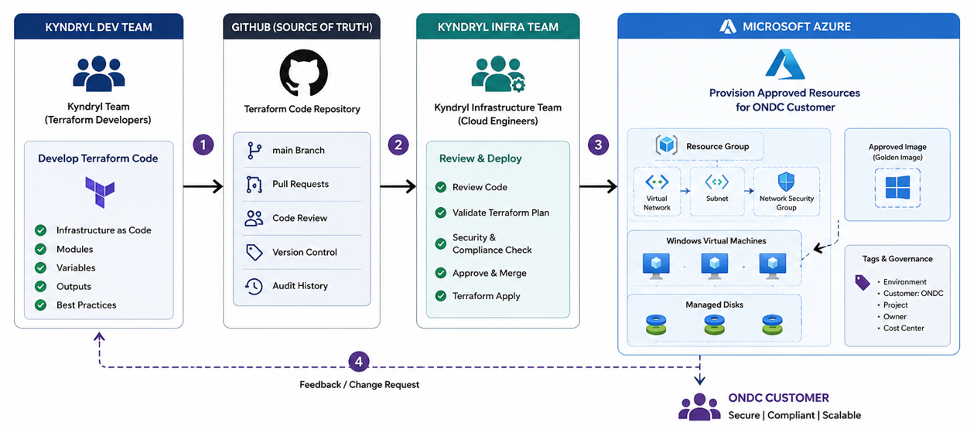

4. Project Scope

In Scope
- Resource Group creation
- Virtual Network
- Subnet
- Network Security Group
- NSG Rules (3389 and 80)
- Public IP
- Network Interface
- Windows Server 2022 Virtual Machine
- IIS Installation
- Managed Disk Creation
- Disk Attachment
- VM Resize
- Resource Tagging
- Terraform Outputs
- User Acceptance Testing
- Project Documentation

Out of Scope
- Azure Load Balancer
- Azure Application Gateway
- Azure SQL Database
- Azure Kubernetes Service
- Azure Backup
- Azure Site Recovery
- Azure Monitor
- Azure Policy
- Azure Firewall
- Azure DevOps CI/CD Pipeline

5. Project Deliverables
- Terraform Source Code
- Resource Group
- Virtual Network
- Subnet
- Network Security Group
- Public IP Address
- Network Interface
- Windows Virtual Machine
- IIS Web Server
- Managed Data Disk
- Resource Tags
- Terraform Outputs
- Test Report
- UAT Report
- Project Documentation

6. Project Assumptions
- Azure subscription is available.
- Students have Contributor permissions.
- Terraform is installed.
- Azure CLI is installed.
- Internet connectivity is available.
- Required software is installed before the project begins.

7. Project Constraints
- Project duration is limited to five working days.
- Azure subscription quotas may apply.
- Budget is limited to the provided Azure subscription.
- Students must use Terraform for infrastructure deployment.
- All deliverables must be completed within the scheduled timeline.

8. Project Milestones
Milestone | Duration
Project Planning | Day 1
Infrastructure Design | Day 1
Azure Infrastructure Deployment | Day 2
Windows Configuration & IIS Installation | Day 3
Disk Attachment & VM Resize | Day 4
Testing & Documentation | Day 5

9. Success Criteria
The project will be considered successful when:
- All Terraform code executes successfully.
- Azure infrastructure is deployed without critical errors.
- Windows VM is accessible using Remote Desktop.
- IIS website is accessible through HTTP.
- Managed disk is successfully attached.
- VM resizing is completed successfully.
- Resource tags are applied correctly.
- UAT pass rate is at least 95%.
- Documentation is complete and approved.

9.1 Success Metrics (KPIs)
KPI | Target
Schedule Performance | ≥90%
Budget Variance | <10%
UAT Pass Rate | ≥95%
Deployment Success | ≥95%
Resource Availability | 100%
Security Compliance | 100%

10. Stakeholders
Stakeholder | Responsibility
Project Sponsor | Project approval and oversight
Instructor | Technical guidance and evaluation
Project Manager | Project planning and coordination
Cloud Infrastructure Engineer | Azure resource deployment
Terraform Developer | Infrastructure as Code implementation
System Administrator | Windows configuration and IIS installation
QA Engineer | Testing and validation
Documentation Lead | Project documentation

11. Team Roles
Role | Responsibility
Project Manager | Planning, monitoring, reporting
Cloud Engineer | Azure resource deployment
Terraform Developer | Terraform development
System Administrator | Windows administration
Security Engineer | NSG and network security
QA Engineer | UAT execution
Documentation Lead | Final documentation

12. Risk Summary
Risk | Impact | Mitigation
Authentication failure | High | Validate Azure login before deployment
Terraform syntax errors | High | Execute terraform validate
NSG misconfiguration | High | Verify security rules before testing
Azure quota limitations | Medium | Validate quotas before deployment
Resource naming conflicts | Medium | Use unique naming standards
Deployment cost | Medium | Destroy resources after completion

13. High-Level Schedule
Phase | Planned Completion
Planning | 65%
Design | 60%
Implementation | 52%
Testing | 45%
Documentation | 40%

14. Budget Estimate
Category | Estimated Cost
Azure Virtual Machine | $25
Managed Disk | $5
Public IP | $2
Networking | $3
Miscellaneous Azure Resources | $5
Estimated Total | $40

15. Communication Plan
Meeting | Frequency | Participants
Project Kick-off | Once | Entire Team
Daily Stand-up | Daily | Project Team
Progress Review | Every Two Days | Instructor & Team
UAT Review | End of Project | QA Team & Instructor
Final Presentation | Project Completion | All Stakeholders

16. Project Approval
Role | Name | Signature | Date
Project Sponsor
Instructor
Project Manager
QA Lead

17. Project Approval Statement
This Project Charter formally authorizes the Azure Windows VM Deployment using Terraform project. The project team is authorized to utilize the assigned resources and execute the activities described in this document to achieve the stated objectives within the approved scope, schedule, and constraints.

18.Project Closure Checklist
- ☐ All Terraform code committed
- ☐ All Azure resources deployed
- ☐ UAT completed
- ☐ Documentation completed
- ☐ Instructor approval received
- ☐ Resources destroyed
- ☐ Lessons Learned documented

